**PROGRAM 1: VISITCARD**

**Activity_main.xml**

*<?*xml version="1.0" encoding="utf-8"*?>*

<RelativeLayout xmlns:android="http://schemas.android.com/apk/res/android" xmlns:app="http://schemas.android.com/apk/res-auto" xmlns:tools="http://schemas.android.com/tools" android:layout_width="match_parent" android:layout_height="match_parent"

tools:context=".MainActivity">

<TextView

android:id="@+id/textView" android:layout_width="wrap_content" android:layout_height="wrap_content" android:layout_alignParentEnd="true" android:layout_alignParentRight="true" android:layout_alignParentBottom="true" android:layout_marginStart="17dp" android:layout_marginLeft="17dp" android:layout_marginTop="17dp" android:layout_marginEnd="168dp" android:layout_marginRight="168dp" android:layout_marginBottom="498dp"

android:text="SSIT"

android:textSize="38dp" />

<ImageView

android:id="@+id/imageView" android:layout_width="290dp" android:layout_height="174dp" android:layout_alignParentEnd="true" android:layout_alignParentRight="true" android:layout_alignParentBottom="true" android:layout_marginEnd="-26dp" android:layout_marginRight="-26dp" android:layout_marginBottom="517dp"

app:srcCompat="@drawable/ssit" />

<View

android:id="@+id/view" android:layout_width="wrap_content" android:layout_height="4dp" android:layout_alignParentBottom="true" android:layout_marginBottom="483dp"

android:background="#4444" />

<TextView android:id="@+id/textView2" android:layout_width="wrap_content" android:layout_height="wrap_content" android:layout_alignParentEnd="true" android:layout_alignParentRight="true" android:layout_alignParentBottom="true" android:layout_marginEnd="131dp" android:layout_marginRight="131dp" android:layout_marginBottom="420dp" android:text="Subhash C S" android:textSize="30dp"

android:textStyle="bold" />

<TextView android:id="@+id/textView3" android:layout_width="wrap_content" android:layout_height="wrap_content" android:layout_alignParentEnd="true" android:layout_alignParentRight="true" android:layout_alignParentBottom="true" android:layout_marginEnd="80dp" android:layout_marginRight="80dp" android:layout_marginBottom="379dp" android:text="Assistant Professor-ISE"

android:textSize="25dp" />

<TextView android:id="@+id/textView4" android:layout_width="wrap_content" android:layout_height="wrap_content" android:layout_alignParentEnd="true" android:layout_alignParentRight="true" android:layout_alignParentBottom="true" android:layout_marginEnd="129dp" android:layout_marginRight="129dp" android:layout_marginBottom="342dp" android:text="Ph No: 9988776655"

android:textSize="20dp" />

<TextView android:id="@+id/textView5" android:layout_width="wrap_content" android:layout_height="wrap_content" android:layout_alignParentEnd="true" android:layout_alignParentRight="true" android:layout_alignParentBottom="true" android:layout_marginEnd="89dp" android:layout_marginRight="89dp" android:layout_marginBottom="300dp" android:text="SSIT,TUMAKURU,572105"

android:textSize="20dp" />

<TextView android:id="@+id/textView6" android:layout_width="wrap_content" android:layout_height="wrap_content" android:layout_alignParentEnd="true" android:layout_alignParentRight="true" android:layout_alignParentBottom="true" android:layout_marginEnd="75dp" android:layout_marginRight="75dp" android:layout_marginBottom="262dp" android:text="Email: subhashcs@ssit.edu.in" android:textSize="20dp" /> </RelativeLayout>

**MainActivity.java**

***package*** *com.example.visit;*

***import*** *androidx.appcompat.app.AppCompatActivity;*

***import*** *android.os.Bundle;*

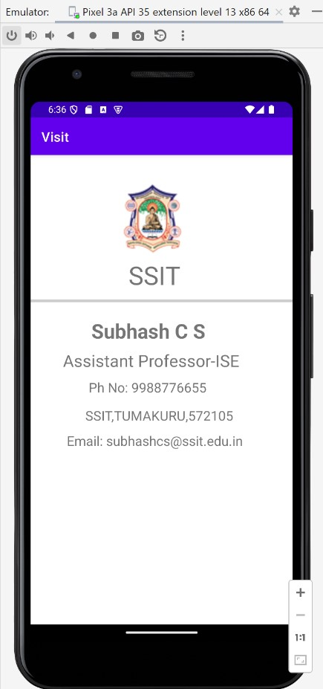

***public class*** *MainActivity* ***extends*** *AppCompatActivity {*

*@Override*

***protected void*** *onCreate(Bundle savedInstanceState) {* ***super****.onCreate(savedInstanceState);*

*setContentView(R.layout.****activity_main****);*

*} }*

**OUTPUT:**

**PROGRAM 2 : SIMPLE CALCULATOR**

**Activity_main.xml**

*<?*xml version="1.0" encoding="utf-8"*?>*

<RelativeLayout xmlns:android="http://schemas.android.com/apk/res/android" xmlns:app="http://schemas.android.com/apk/res-auto" xmlns:tools="http://schemas.android.com/tools" android:layout_width="match_parent" android:layout_height="match_parent"

tools:context=".MainActivity">

<TextView

android:id="@+id/textView" android:layout_width="wrap_content" android:layout_height="wrap_content" android:layout_alignParentEnd="true" android:layout_alignParentBottom="true" android:layout_marginEnd="117dp" android:layout_marginBottom="532dp" android:text="Simple Calculator"

android:textSize="24sp" />

<EditText

android:id="@+id/editText1" android:layout_width="wrap_content" android:layout_height="wrap_content" android:layout_alignParentEnd="true" android:layout_alignParentBottom="true" android:layout_marginEnd="95dp" android:layout_marginBottom="457dp"

android:ems="10" android:hint="Enter the Number1" android:inputType="textPersonName"

android:text="" />

<EditText

android:id="@+id/editText2" android:layout_width="wrap_content" android:layout_height="wrap_content" android:layout_alignParentEnd="true" android:layout_alignParentBottom="true" android:layout_marginEnd="95dp" android:layout_marginBottom="392dp"

android:ems="10" android:hint="Enter the Number2" android:inputType="textPersonName" android:text="" />

<TextView android:id="@+id/textView1" android:layout_width="129dp" android:layout_height="wrap_content" android:layout_alignParentEnd="true" android:layout_alignParentBottom="true" android:layout_marginEnd="123dp" android:layout_marginBottom="319dp"

android:text="0"

android:textSize="34sp" />

<Button android:id="@+id/button" android:layout_width="wrap_content" android:layout_height="wrap_content" android:layout_alignParentEnd="true" android:layout_alignParentBottom="true" android:layout_marginEnd="245dp" android:layout_marginBottom="243dp" android:onClick="add" android:text="ADD" />

<Button android:id="@+id/button2" android:layout_width="wrap_content" android:layout_height="wrap_content" android:layout_alignParentEnd="true" android:layout_alignParentBottom="true" android:layout_marginEnd="56dp" android:layout_marginBottom="243dp" android:onClick="sub" android:text="SUB" />

<Button android:id="@+id/button3" android:layout_width="wrap_content" android:layout_height="wrap_content" android:layout_alignParentEnd="true" android:layout_alignParentBottom="true" android:layout_marginEnd="240dp" android:layout_marginBottom="170dp" android:onClick="mul"

android:text="MUL" />

<Button android:id="@+id/button4" android:layout_width="wrap_content" android:layout_height="wrap_content" android:layout_alignParentEnd="true" android:layout_alignParentBottom="true" android:layout_marginEnd="53dp" android:layout_marginBottom="165dp"

android:onClick="div" android:text="DIV" /> </RelativeLayout>

**MainActivity.java**

package com.example.calculator;

import androidx.appcompat.app.AppCompatActivity;

import android.os.Bundle; import android.view.View; import android.widget.EditText;

import android.widget.TextView;

public class MainActivity extends AppCompatActivity {

EditText e1,e2;

TextView tv1;

@Override

protected void onCreate(Bundle savedInstanceState) { super.onCreate(savedInstanceState); setContentView(R.layout.*activity_main*); e1=(EditText)findViewById(R.id.*editText1*); e2=(EditText)findViewById(R.id.*editText2*);

tv1=(TextView)findViewById(R.id.*textView1*);

}

public void add(View view){

int a1 = Integer.*parseInt*(e1.getText().toString()); int a2 = Integer.*parseInt*(e2.getText().toString()); int result= a1+a2;

tv1.setText(""+result);

}

public void sub(View view){

int a1 = Integer.*parseInt*(e1.getText().toString()); int a2 = Integer.*parseInt*(e2.getText().toString());

int result= a1-a2;

tv1.setText(""+result);

}

public void mul(View view){

int a1 = Integer.*parseInt*(e1.getText().toString()); int a2 = Integer.*parseInt*(e2.getText().toString()); int result= a1*a2;

tv1.setText(""+result);

}

public void div(View view){ int a1 = Integer.*parseInt*(e1.getText().toString()); int a2 = Integer.*parseInt*(e2.getText().toString()); float result= a1/a2;

tv1.setText(""+result);

} }

**OUTPUT:**

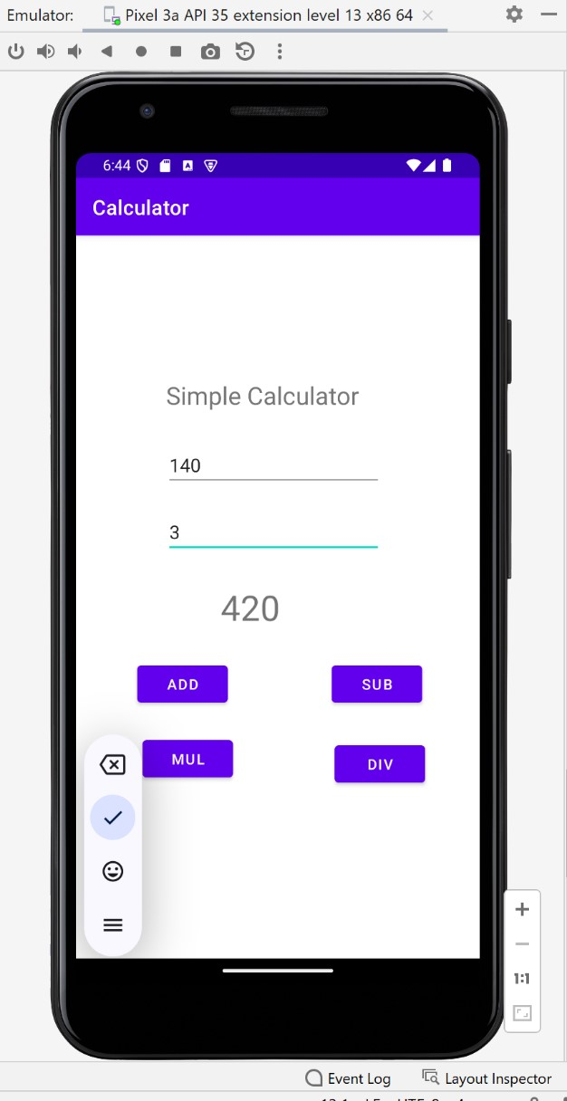

**PROGRAM 3 : COUNTER APPLICATION**

**Activity_main.xml**

<?xml version="1.0" encoding="utf-8"?>

<RelativeLayout xmlns:android="http://schemas.android.com/apk/res/android" xmlns:app="http://schemas.android.com/apk/res-auto" xmlns:tools="http://schemas.android.com/tools" android:layout_width="match_parent" android:layout_height="match_parent" tools:context=".MainActivity">

<TextView

android:layout_width="378dp" android:layout_height="68dp" android:layout_alignParentEnd="true" android:layout_alignParentBottom="true" android:layout_marginEnd="18dp" android:layout_marginBottom="602dp" android:text="Counter Application" android:textSize="38dp"

app:layout_constraintBottom_toBottomOf="parent" app:layout_constraintLeft_toLeftOf="parent" app:layout_constraintRight_toRightOf="parent" app:layout_constraintTop_toTopOf="parent" />

<TextView

android:id="@+id/textView" android:layout_width="121dp" android:layout_height="32dp" android:layout_alignParentEnd="true" android:layout_alignParentBottom="true" android:layout_marginEnd="145dp" android:layout_marginBottom="478dp" android:text="Counter Value" />

<Button

android:id="@+id/btn_start" android:layout_width="wrap_content" android:layout_height="wrap_content" android:layout_alignParentEnd="true" android:layout_alignParentBottom="true" android:layout_marginEnd="297dp" android:layout_marginBottom="295dp" android:text="Start" />

<Button android:id="@+id/btn_stop" android:layout_width="wrap_content" android:layout_height="wrap_content" android:layout_alignParentEnd="true" android:layout_alignParentBottom="true" android:layout_marginEnd="74dp" android:layout_marginBottom="292dp" android:text="Stop" /> </RelativeLayout>

**MainActivity.java**

package com.example.counter;

import androidx.appcompat.app.AppCompatActivity; import android.os.Bundle; import android.os.Handler; import android.view.View; import android.widget.Button; import android.widget.TextView;

public class MainActivity extends AppCompatActivity {

Button btnstart, btnstop; TextView txtcounter; int i=1;

Handler customHandler=new Handler();

@Override

protected void onCreate(Bundle savedInstanceState) { super.onCreate(savedInstanceState); setContentView(R.layout.*activity_main*); btnstart=findViewById(R.id.*btn_start*); btnstop=findViewById(R.id.*btn_stop*); txtcounter=findViewById(R.id.*textView*);

btnstart.setOnClickListener(new View.OnClickListener() {

@Override public void onClick(View v) {

customHandler.postDelayed(updateTimerThread,0);

}

});

btnstop.setOnClickListener(new View.OnClickListener() {

@Override public void onClick(View v) {

customHandler.removeCallbacks(updateTimerThread);

}

});

}

private final Runnable updateTimerThread=new Runnable() {

@Override public void run() { txtcounter.setText(""+i); customHandler.postDelayed(this,1000); i++;

}

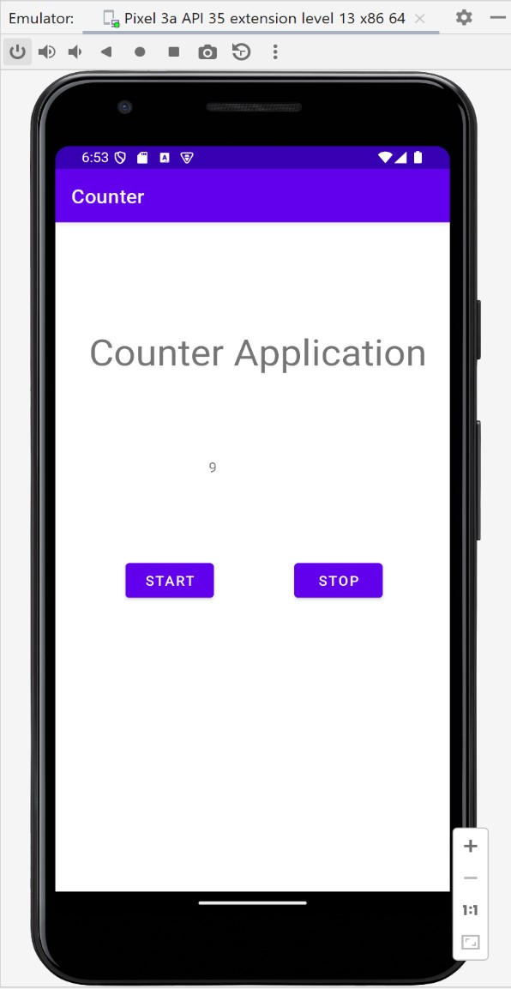 }; }

**OUTPUT:**

**PROGRAM 4 : TEXT-TO-SPEECH**

**Activity_main.xml**

*<?*xml version="1.0" encoding="utf-8"*?>*

<RelativeLayout xmlns:android="http://schemas.android.com/apk/res/android" xmlns:app="http://schemas.android.com/apk/res-auto" xmlns:tools="http://schemas.android.com/tools" android:layout_width="match_parent" android:layout_height="match_parent"

tools:context=".MainActivity">

<TextView

android:id="@+id/textView" android:layout_width="wrap_content" android:layout_height="wrap_content" android:layout_alignParentEnd="true" android:layout_alignParentRight="true" android:layout_alignParentBottom="true" android:layout_marginEnd="53dp" android:layout_marginRight="53dp" android:layout_marginBottom="537dp" android:text="Text2SpeechApp"

android:textSize="40dp" />

<EditText

android:id="@+id/editText" android:layout_width="wrap_content" android:layout_height="wrap_content" android:layout_alignParentEnd="true" android:layout_alignParentRight="true" android:layout_alignParentBottom="true" android:layout_marginEnd="101dp" android:layout_marginRight="101dp" android:layout_marginBottom="383dp"

android:ems="10"

android:hint="Enter the text to be converted" android:inputType="textPersonName"

android:text="" />

<Button

android:id="@+id/button" android:layout_width="wrap_content" android:layout_height="wrap_content" android:layout_alignParentEnd="true" android:layout_alignParentRight="true" android:layout_alignParentBottom="true" android:layout_marginEnd="154dp" android:layout_marginRight="154dp" android:layout_marginBottom="256dp" android:onClick="convert" android:text="Convert" /> </RelativeLayout>

**MainActivity.java**

**package** com.example.texttospeech;

**import** androidx.appcompat.app.AppCompatActivity; **import** android.os.Bundle; **import** android.speech.tts.TextToSpeech; **import** android.view.View; **import** android.widget.EditText; **import** android.widget.Toast; **import** java.util.Locale;

**public class** MainActivity **extends** AppCompatActivity {

TextToSpeech **t1**;

EditText **e1**; @Override

**protected void** onCreate(Bundle savedInstanceState) { **super**.onCreate(savedInstanceState); setContentView(R.layout.***activity_main***); **e1** = findViewById(R.id.***editText***);

**t1** = **new** TextToSpeech(getApplicationContext(), **new**

TextToSpeech.OnInitListener() {

@Override **public void** onInit(**int** status) { **if** (status!=TextToSpeech.***ERROR***){

**t1**.setLanguage(Locale.***UK***);

}

}

});

}

**public void** convert(View view){ String tospeak = **e1**.getText().toString();

**t1**.speak(tospeak,TextToSpeech.***QUEUE_FLUSH***,**null**);

} }

**OUTPUT:**

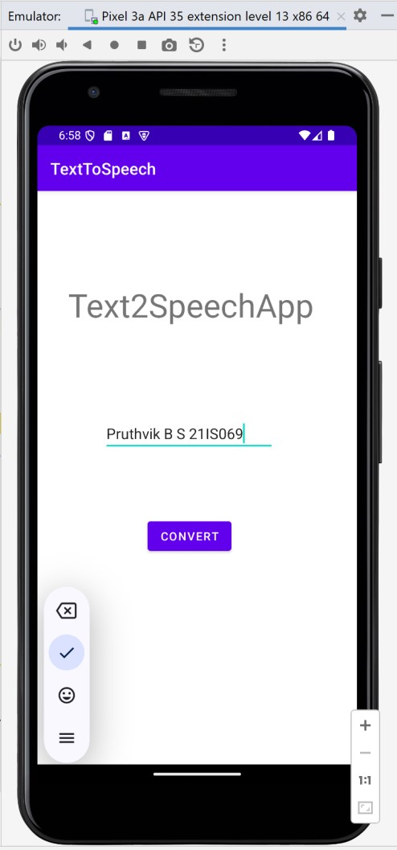

Prgm : 05 Wallpaper Changing App **MainActivity.java**

**package** com.example.wallapaper;

**import** androidx.appcompat.app.AppCompatActivity; **import** android.app.WallpaperManager; **import** android.graphics.Bitmap; **import** android.graphics.drawable.BitmapDrawable; **import** android.graphics.drawable.Drawable; **import** android.os.Bundle; **import** android.view.View; **import** android.widget.Button; **import** java.io.IOException; **import** java.util.Timer;

**import** java.util.TimerTask;

**public class** MainActivity **extends** AppCompatActivity {

Button **changewallpaper**;

Timer **mytimer**;

Drawable **drawable**; WallpaperManager **wpm**;

**int prev** = 1;

@Override

**protected void** onCreate(Bundle savedInstanceState) { **super**.onCreate(savedInstanceState);

setContentView(R.layout.***activity_main***);

**mytimer** = **new** Timer();

**wpm** = WallpaperManager.*getInstance*(**this**);

**changewallpaper** = findViewById(R.id.***button***);

**changewallpaper**.setOnClickListener(**new** View.OnClickListener() {

@Override

**public void** onClick(View view) {

setWallpaper();

}

});

}

**private void** setWallpaper() { **mytimer**.schedule(**new** TimerTask() {

@Override **public void** run() {

**if** (**prev** == 1) {

**drawable** = getResources().getDrawable(R.drawable.***one***); **prev** = 2; } **else if** (**prev** == 2) {

**drawable** = getResources().getDrawable(R.drawable.***two***); **prev** = 3; } **else if** (**prev** == 3) {

**drawable** = getResources().getDrawable(R.drawable.***three***); **prev** = 4; } **else if** (**prev** == 4) {

**drawable** = getResources().getDrawable(R.drawable.***four***); **prev** = 5; } **else if** (**prev** == 5) {

**drawable** = getResources().getDrawable(R.drawable.***five***); **prev** = 1;

}

Bitmap wallpaper = ((BitmapDrawable) **drawable**).getBitmap(); **try** {

**wpm**.setBitmap(wallpaper); } **catch** (IOException e) { e.printStackTrace();

}

}

}, 0, 30000);

} }

# activity_main.xml

*<?*xml version="1.0" encoding="utf-8"*?>*

<RelativeLayout xmlns:android="http://schemas.android.com/apk/res/android" android:layout_width="match_parent" android:layout_height="match_parent" android:padding="16dp"

android:background="@android:color/white">

<TextView

android:layout_width="395dp" android:layout_height="54mm" android:layout_alignParentEnd="true" android:layout_alignParentBottom="true" android:layout_marginEnd="3dp" android:layout_marginBottom="178dp" android:text="Wallpaper Changing Application" android:textSize="38dp" />

<Button

android:id="@+id/button" android:layout_width="wrap_content" android:layout_height="wrap_content" android:text="Change Wallpaper" android:layout_centerInParent="true" android:padding="16dp"

android:background="@android:color/holo_blue_light" android:textColor="@android:color/white" android:textStyle="bold" />

</RelativeLayout>

OUTPUT: Wallpaper changes for every 30000ms

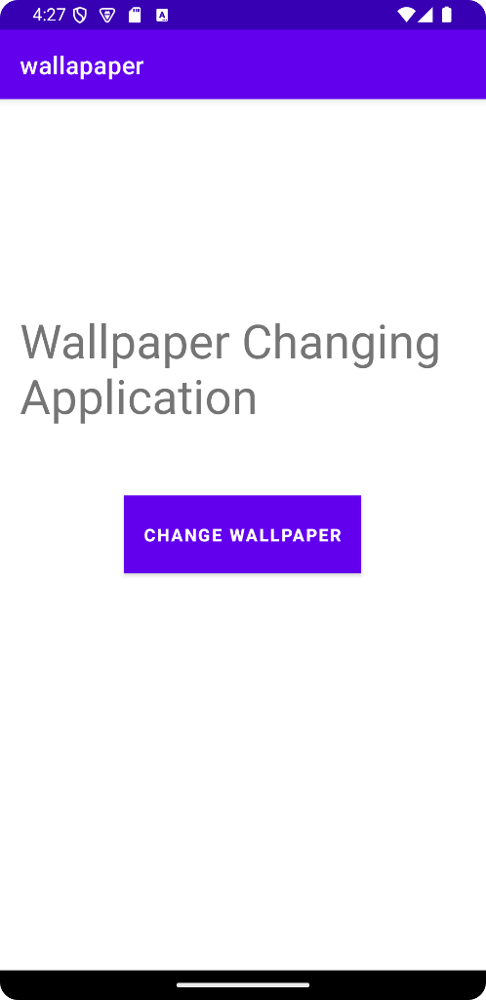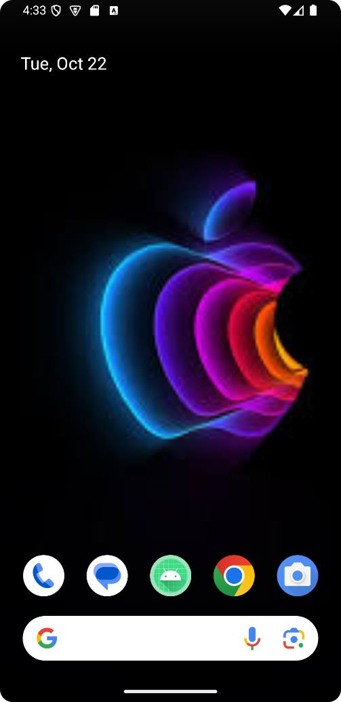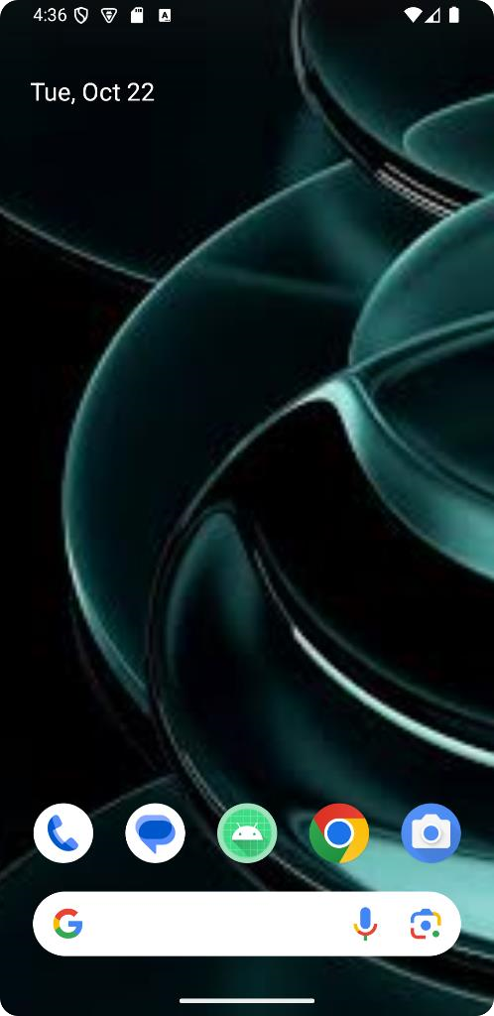

# Program 06 : phone dialler MainActivity.java

package com.example.phonekey;

import android.content.Intent; import android.net.Uri; import android.os.Bundle; import android.provider.ContactsContract; import android.view.View; import android.widget.Button; import android.widget.EditText;

import androidx.appcompat.app.AppCompatActivity;

public class MainActivity extends AppCompatActivity {

EditText phoneNumberEditText;

Button clearBtn, callBtn, saveBtn;

@Override

protected void onCreate(Bundle savedInstanceState) { super.onCreate(savedInstanceState);

setContentView(R.layout.*activity_main*);

phoneNumberEditText = findViewById(R.id.*phoneNumberEditText*);

clearBtn = findViewById(R.id.*clearBtn*); callBtn = findViewById(R.id.*callBtn*);

saveBtn = findViewById(R.id.*saveBtn*);

*// Clear button functionality*

clearBtn.setOnClickListener(new View.OnClickListener() {

@Override

public void onClick(View v) {

phoneNumberEditText.setText("");

}

});

*// Call button functionality*

callBtn.setOnClickListener(new View.OnClickListener() {

@Override

public void onClick(View v) {

String phoneNumber = phoneNumberEditText.getText().toString(); Intent intent = new Intent(Intent.*ACTION_DIAL*); intent.setData(Uri.*parse*("tel:" + phoneNumber));

startActivity(intent);

}

});

*// Save button functionality*

saveBtn.setOnClickListener(new View.OnClickListener() {

@Override

public void onClick(View v) {

String phoneNumber = phoneNumberEditText.getText().toString(); Intent intent = new Intent(Intent.*ACTION_INSERT*); intent.setType(ContactsContract.Contacts.*CONTENT_TYPE*); intent.putExtra(ContactsContract.Intents.Insert.*PHONE*, phoneNumber); startActivity(intent);

}

});

}

*// Method to append input number when number buttons are clicked*

public void inputNumber(View v) {

Button btn = (Button) v;

String digit = btn.getText().toString();

String phoneNumber = phoneNumberEditText.getText().toString(); phoneNumberEditText.setText(phoneNumber + digit);

} }

# activitymain.xml

*<?*xml version="1.0" encoding="utf-8"*?>*

<LinearLayout xmlns:android="http://schemas.android.com/apk/res/android" android:layout_width="match_parent" android:layout_height="match_parent" android:orientation="vertical" android:padding="16dp"

android:gravity="center">

<EditText

android:id="@+id/phoneNumberEditText" android:layout_width="match_parent" android:layout_height="wrap_content" android:hint="Enter phone number" android:inputType="phone" android:gravity="center" android:textSize="18sp" android:padding="10dp"

android:layout_marginBottom="16dp"/>

*<!-- Clear, Call, and Save buttons -->*

<GridLayout

android:layout_width="match_parent" android:layout_height="222dp" android:layout_marginBottom="16dp" android:columnCount="3"

android:rowCount="4">

*<!-- Buttons for number input -->*

<Button style="@style/ButtonNumber" android:onClick="inputNumber"

android:text="1" />

<Button style="@style/ButtonNumber" android:onClick="inputNumber"

android:text="2" />

<Button style="@style/ButtonNumber" android:onClick="inputNumber"

android:text="3" />

<Button style="@style/ButtonNumber" android:onClick="inputNumber"

android:text="4" />

<Button style="@style/ButtonNumber" android:onClick="inputNumber"

android:text="5" />

<Button style="@style/ButtonNumber" android:onClick="inputNumber"

android:text="6" />

<Button style="@style/ButtonNumber" android:onClick="inputNumber"

android:text="7" />

<Button style="@style/ButtonNumber" android:onClick="inputNumber"

android:text="8" />

<Button style="@style/ButtonNumber" android:onClick="inputNumber"

android:text="9" />

<View android:layout_width="0dp" android:layout_height="0dp"

android:layout_columnSpan="1" />

<Button style="@style/ButtonNumber" android:onClick="inputNumber"

android:text="0" />

<View android:layout_width="0dp" android:layout_height="0dp"

android:layout_columnSpan="1" />

</GridLayout>

<LinearLayout android:layout_width="match_parent" android:layout_height="wrap_content" android:orientation="horizontal"

android:gravity="center">

<Button android:id="@+id/clearBtn" android:layout_width="0dp" android:layout_height="wrap_content" android:layout_weight="1" android:text="Clear"

android:textSize="16sp" />

<Button android:id="@+id/callBtn" android:layout_width="0dp" android:layout_height="wrap_content" android:layout_weight="1" android:text="Call"

android:textSize="16sp" />

<Button

android:id="@+id/saveBtn" android:layout_width="0dp" android:layout_height="wrap_content" android:layout_weight="1" android:text="Save" android:textSize="16sp" />

</LinearLayout>

</LinearLayout>

**In res/values/style.xml add this.**

*<?*xml version="1.0" encoding="utf-8"*?>*

<resources>

*<!-- Define the ButtonNumber style -->*

<style name="ButtonNumber">

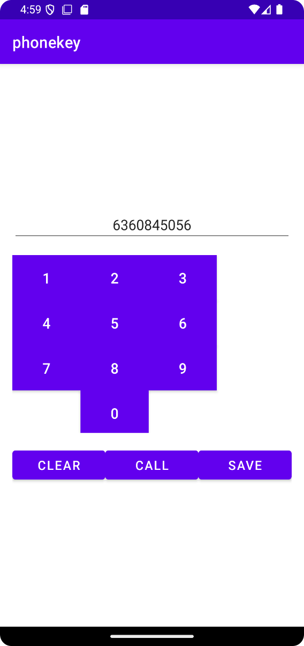 <item name="android:layout_width">wrap_content</item>

<item name="android:layout_height">wrap_content</item>

<item name="android:textColor">#FFFFFF</item>

<item name="android:background">#FF9800</item>

<item name="android:padding">10dp</item>

<item name="android:textSize">18sp</item>

</style>

</resources> **Output:**

**Prg 07: Create two files of XML and JSON type with values for City_Name, Latitude, Longitude,**

**Temperature, and Humidity. Develop an application to create an activity with two buttons to parse the XML and JSON files which when clicked should display the data in their respective layouts side by side.**

**MainActivity.java**

package com.example.jsonxmlparsing;

import android.os.Bundle; import android.util.Log; import android.view.View; import android.widget.Button; import android.widget.TextView; import android.widget.Toast;

import androidx.appcompat.app.AppCompatActivity;

import org.json.JSONArray; import org.json.JSONException; import org.json.JSONObject; import org.w3c.dom.Document; import org.w3c.dom.Element; import org.w3c.dom.Node; import org.w3c.dom.NodeList; import java.io.IOException; import java.io.InputStream;

import java.nio.charset.StandardCharsets; import javax.xml.parsers.DocumentBuilder;

import javax.xml.parsers.DocumentBuilderFactory;

public class MainActivity extends AppCompatActivity {

Button parseXmlBtn, parseJsonBtn;

TextView displayTextView;

@Override

protected void onCreate(Bundle savedInstanceState) { super.onCreate(savedInstanceState);

setContentView(R.layout.*activity_main*);

parseJsonBtn = findViewById(R.id.*parseJsonBtn*); parseXmlBtn = findViewById(R.id.*parseXmlBtn*); displayTextView = findViewById(R.id.*displayTextView*);

*// Parsing XML*

parseXmlBtn.setOnClickListener(new View.OnClickListener() {

@Override

public void onClick(View v) { try {

InputStream is = getAssets().open("city.xml");

DocumentBuilderFactory documentBuilderFactory =

DocumentBuilderFactory.*newInstance*();

DocumentBuilder documentBuilder = documentBuilderFactory.newDocumentBuilder();

Document document = documentBuilder.parse(is);

StringBuilder stringBuilder = new StringBuilder(); stringBuilder.append("XML Data"); stringBuilder.append("\n----------");

NodeList nodeList = document.getElementsByTagName("place"); for (int i = 0; i < nodeList.getLength(); i++) { Node node = nodeList.item(i);

if (node.getNodeType() == Node.*ELEMENT_NODE*) { Element element = (Element) node;

stringBuilder.append("\nName: ").append(getValue("name", element)); stringBuilder.append("\nLatitude: ").append(getValue("lat", element)); stringBuilder.append("\nLongitude: ").append(getValue("long", element)); stringBuilder.append("\nTemperature: ").append(getValue("temperature", element)); stringBuilder.append("\nHumidity: ").append(getValue("humidity", element)); stringBuilder.append("\n----------");

}

}

displayTextView.setText(stringBuilder.toString());

} catch (Exception e) {

e.printStackTrace();

Toast.*makeText*(MainActivity.this, "Error Parsing XML", Toast.*LENGTH_SHORT*).show();

}

}

});

*// Parsing JSON*

parseJsonBtn.setOnClickListener(new View.OnClickListener() {

@Override

public void onClick(View v) {

String json;

StringBuilder stringBuilder = new StringBuilder(); try {

InputStream is = getAssets().open("city.json"); int size = is.available(); byte[] buffer = new byte[size];

is.read(buffer);

json = new String(buffer, StandardCharsets.*UTF_8*);

JSONArray jsonArray = new JSONArray(json); stringBuilder.append("JSON Data"); stringBuilder.append("\n----------");

for (int i = 0; i < jsonArray.length(); i++) {

JSONObject jsonObject = jsonArray.getJSONObject(i);

stringBuilder.append("\nName: ").append(jsonObject.getString("name")); stringBuilder.append("\nLatitude: ").append(jsonObject.getString("lat")); stringBuilder.append("\nLongitude: ").append(jsonObject.getString("long")); stringBuilder.append("\nTemperature: ").append(jsonObject.getString("temperature")); stringBuilder.append("\nHumidity: ").append(jsonObject.getString("humidity")); stringBuilder.append("\n----------");

}

displayTextView.setText(stringBuilder.toString()); is.close();

} catch (IOException | JSONException e) { e.printStackTrace();

Toast.*makeText*(MainActivity.this, "Error Parsing JSON Data",

Toast.*LENGTH_SHORT*).show();

}

}

});

}

*// Helper method to extract XML element value* private String getValue(String tag, Element element) {

return element.getElementsByTagName(tag).item(0).getTextContent();

}

}

activitymain.xml

*<?*xml version="1.0" encoding="utf-8"*?>*

<androidx.constraintlayout.widget.ConstraintLayout xmlns:android="http://schemas.android.com/apk/res/android" xmlns:app="http://schemas.android.com/apk/res-auto" xmlns:tools="http://schemas.android.com/tools" android:layout_width="match_parent" android:layout_height="match_parent"

tools:context=".MainActivity"

android:padding="16dp">

<TextView

android:id="@+id/titleTextView" android:layout_width="wrap_content" android:layout_height="wrap_content" android:text="PARSING XML AND JSON DATA"

android:textSize="18sp" android:textStyle="bold" android:textColor="#000" android:layout_marginBottom="20dp" app:layout_constraintTop_toTopOf="parent" app:layout_constraintStart_toStartOf="parent"

app:layout_constraintEnd_toEndOf="parent" />

<Button

android:id="@+id/parseXmlBtn" android:layout_width="wrap_content" android:layout_height="wrap_content" android:text="Parse XML Data" android:layout_marginBottom="20dp" android:backgroundTint="@android:color/holo_blue_light" app:layout_constraintTop_toBottomOf="@id/titleTextView" app:layout_constraintStart_toStartOf="parent"

app:layout_constraintEnd_toEndOf="parent" />

<Button

android:id="@+id/parseJsonBtn" android:layout_width="wrap_content" android:layout_height="wrap_content" android:text="Parse JSON Data"

android:backgroundTint="@android:color/holo_green_light" app:layout_constraintTop_toBottomOf="@id/parseXmlBtn" app:layout_constraintStart_toStartOf="parent"

app:layout_constraintEnd_toEndOf="parent" />

<TextView

android:id="@+id/displayTextView" android:layout_width="wrap_content" android:layout_height="wrap_content"

android:text="" android:layout_marginTop="20dp"

app:layout_constraintTop_toBottomOf="@id/parseJsonBtn" app:layout_constraintStart_toStartOf="parent" app:layout_constraintEnd_toEndOf="parent"

android:textColor="#000"

android:textSize="16sp" />

</androidx.constraintlayout.widget.ConstraintLayout>

# City.xml

*<?*xml version="1.0" encoding="utf-8"*?>*

<places>

<place>

<name>Mysore</name>

<lat>12.295</lat>

<long>76.639</long>

<temperature>22</temperature> <humidity>90%</humidity>

</place>

</places> **City.json**

[

{

"name": "Mysore",

"lat": "12.295",

"long": "76.639",

"temperature": "22",

"humidity": "90%"

} ]

**OUTPUT:**

